**ALAGAPPA GOVERNMENT ARTS COLLEGE**

**KARAIKUDI – 630003**

**NAAN MUDHALVAN PROJECT**



PROJECT NAME:

ANALYSING HOUSING PRICES IN METROPOLITAN AREAS OF INDIA

**1. INTRODUCTION**

1.1 Overview

1.2 Purpose

**2. PROBLEM DEFINITION & DESIGN THINKING**

2.1 Empathy Map

2.2 Ideation & Brainstorming Map

**3. RESULT**

3.1 Data model

3.2 Activity & Screenshot

**4. TRAINHEAD PROFILE PUBLIC URL**

**5. ADVANTAGES & DISADVANTAGES**

**6. APPLICATIONS**

**7. CONCLUSION**

**8. FUTURES**

**1. INTRODUCTION**

**1.1 OVERVIEW**

The housing markets can be highly localized and subject to unique dynamics, so it's crucial to tailor your analysis to the specific metropolitan area you are studying. Additionally, collaboration with local experts and real estate professionals can provide valuable insights. Gather data on housing prices from reliable sources such as real estate websites, government agencies, and real estate market reports. This data should include information on property types, locations, sizes, and prices.

**1.2 PURPOSE**

* + Real Estate Investment
  + Economic Indicator
  + Policy Formulation
  + Research and Education
  + Infrastructure Development

**MILESTONE 1**

**2. PROBLEM DEFINITION & DESIGN THINKING**

**2.1 EMPATHY MAP**

<https://github.com/aluau0121bma0413/Analyzing-Housing-prices-in-Metropolitan-areas-of-India-NM791348BC5E37497BD3E4FFE795A349B4/blob/main/Empathy%20team%2010.pdf>

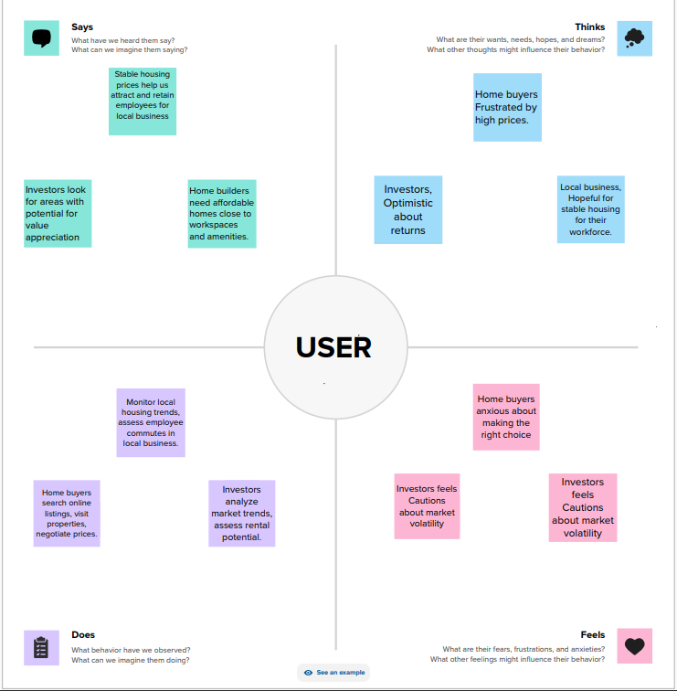

**2.2 IDEATION & BRAINSTORMING MAP**

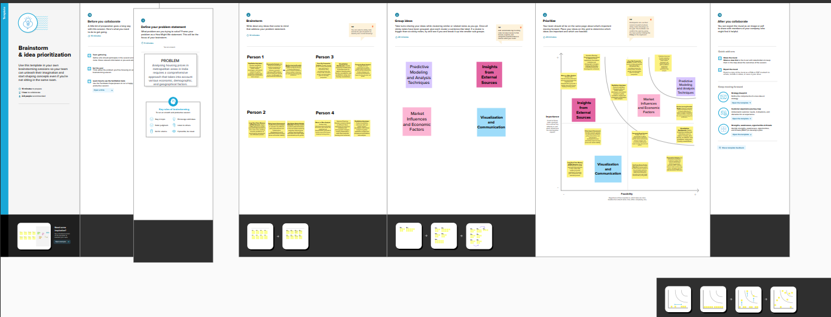<https://github.com/aluau0121bma0413/Analyzing-Housing-prices-in-Metropolitan-areas-of-India-NM791348BC5E37497BD3E4FFE795A349B4/blob/main/Brainstorming%20team%2010.pdf>

**RESULT:**

Keep in mind that housing price analysis is a continuous process, and market conditions can change rapidly. Therefore, it's crucial to keep your analysis updated with the latest data and market trends to make informed decisions.

**MILESTONE 2**

**DATA COLLECTION AND PREPARATION**

**ACTIVITY 1**

**COLLECT THE DATA SET:**

Please use the link to download the dataset: [link](https://www.kaggle.com/datasets/ruchi798/housing-prices-in-metropolitan-areas-of-india)

**ACTIVITY 1.1**

**UNDERSTAND THE DATA:**

Data contains all the meta information regarding the columns described in the CSV files.

**THE SHEETS ARE:**

Connect the dataset in the Tableau.com

* 1. Bangalore.csv
  2. Chennai.csv
  3. Delhi.csv
  4. Hyderabad.csv
  5. Kolkata.csv
  6. Mumbai.csv

**ACTIVITY 2**

**CONNECT DATASET WITH TABLEAU:**

Reference video link:

[Tableau - Book1 2023-05-25 03-08-30.mp4 - Google Drive](https://drive.google.com/file/d/11nyFJ7x2K6-GGWzsQ6S-i-n-SqePkgyE/view)

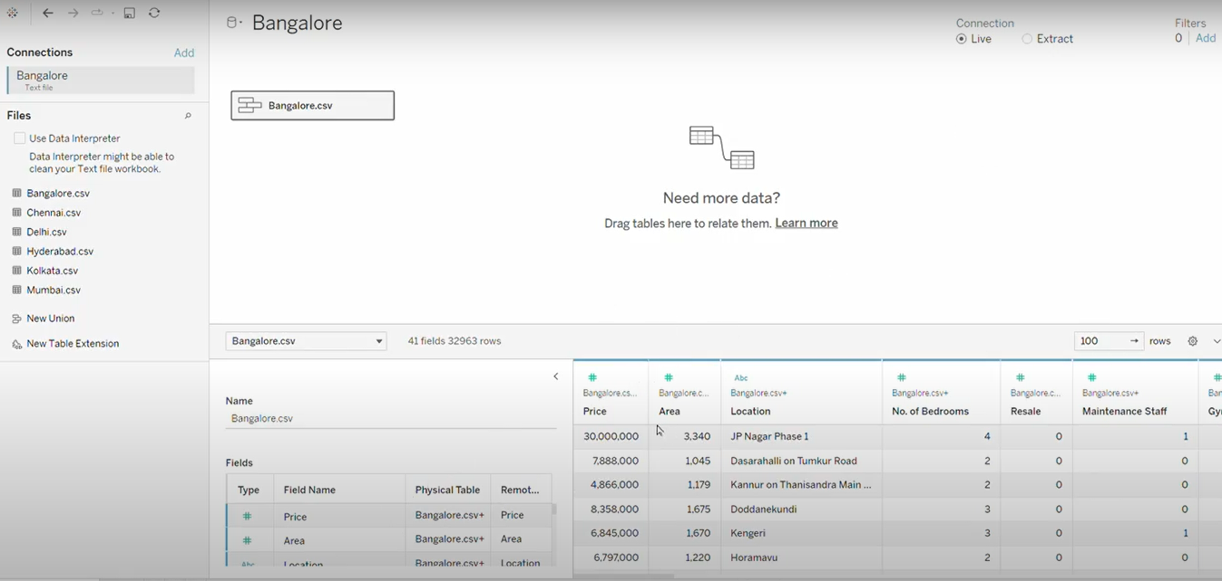

**MILESTONE 3**

**DATA PREPARATION:**

Data modules are containers that describe data and rules for combining and shaping data to prepare it for analysis and visualization in tableau. Data modules can be based on serves, packages, uploaded files, datasets, and other data modules.

**ACTIVITY 1**

**PREPARE THE DATA FOR VISUALIZATION:**

The data for visualization involves cleaning the data to remove irrelevant or missing data, transforming the data into a format that can be easily visualized, exploring the data to identify patterns and trends, filtering the data to focus on specific subsets of data, preparing the data for visualization software, and ensuring the data is accurate and complete. This process helps to make the data easily understandable and ready for creating visualizations to gain insights into performance and efficiency.

**MILESTONE 4**

**DATA VISUALIZATION:**

Data visualization is the process of creating graphical representations of data to help people understand and explore the information. The goal of data visualization is to make complex data sets more accessible, intuitive, and easier to interpret. By using visual elements such as charts, graphs, and maps, data visualizations can help people quickly identify patterns, trends, and outliers in the data.

**ACTIVITY 1:**

**NUMBER OF UNIQUE VISUALIZATIONS:**

The number of unique visualizations that can be created with a given dataset. Some common types of visualizations that can be used to analyze the performance and efficiency of Radisson Hotels include bar charts, line charts, heat maps, scatter plots, pie charts, Maps etc. These visualizations can be used to compare performance, track changes over time, show distribution, relationships between variables, breakdown of revenue and customer demographics, workload, resource allocation and location of hotels.

**ACTIVITY 1.1:**

**LATITUDE AND LONGITUDE BASED ON LOCATION:**

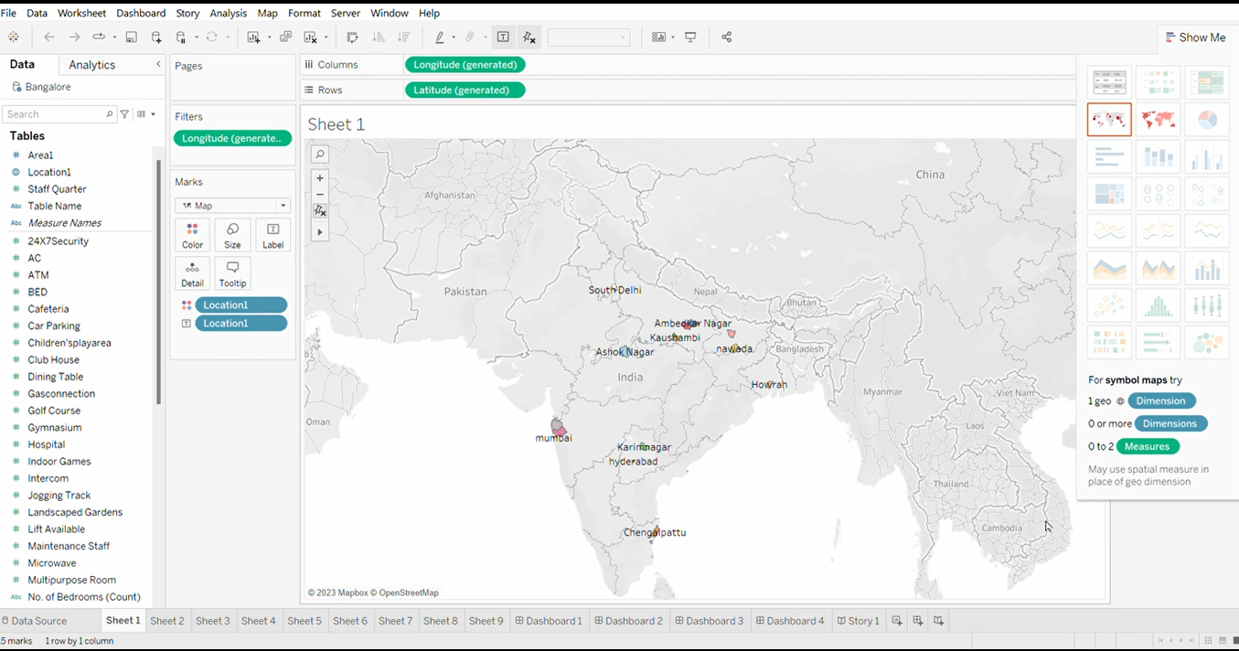

* + Click on the sheet1 the page will be appear.
  + Click the longitude and drag into X-axis.
  + Then click the latitude in Y-axis.
  + Make a filters in longitude in the filter box.
  + Then drag the location to the color and text.
  + Then select the map option.
  + Then finally the values are appear in the sheet1.
  + Finally save the map as sheet1.

**ACTIVITY 1.2**

**NUMBER OF HOUSES BASED ON AREA IN SQUARE FEET:**

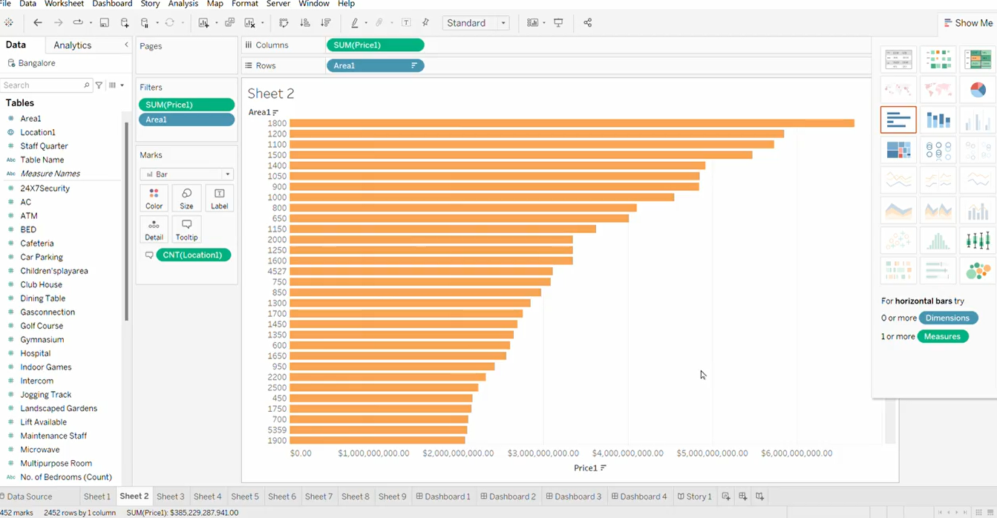

* + Click on the sheet 2 then the page appear.
  + Click sum(price) and drag to X-axis.
  + Then click area and drag Y-axis.
  + Make a filters in price and area.
  + Drag the location in tooltip.
  + Change the option to the Bar.
  + Then finally save the changes in the workbook by clicking save as .

**ACTIVITY 1.3:**

**HOUSES PRICE BASED ON RAINWATER HARVEST PITS**

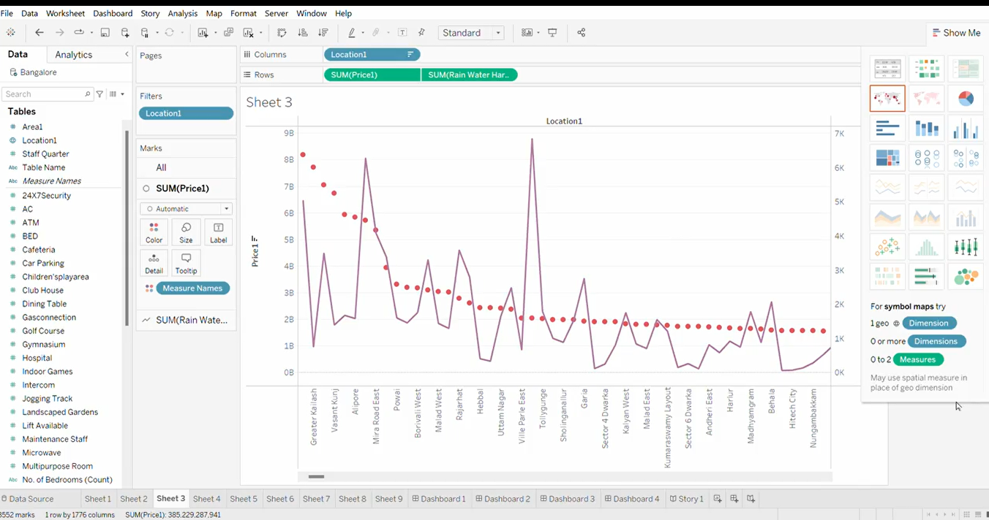

* + Click sheet3.
  + Drag the location to the X-axis.
  + Drag the SUM(price) and SUM(rainwater harvesting) to the Y-axis.
  + Then drag the location1 to the filters.
  + Drag the measure names to the colors.
  + Then save the sheet to the workbook.

**ACTIVITY 1.4:**

**VASTU-COMPLAINS BASED ON LOCATION**

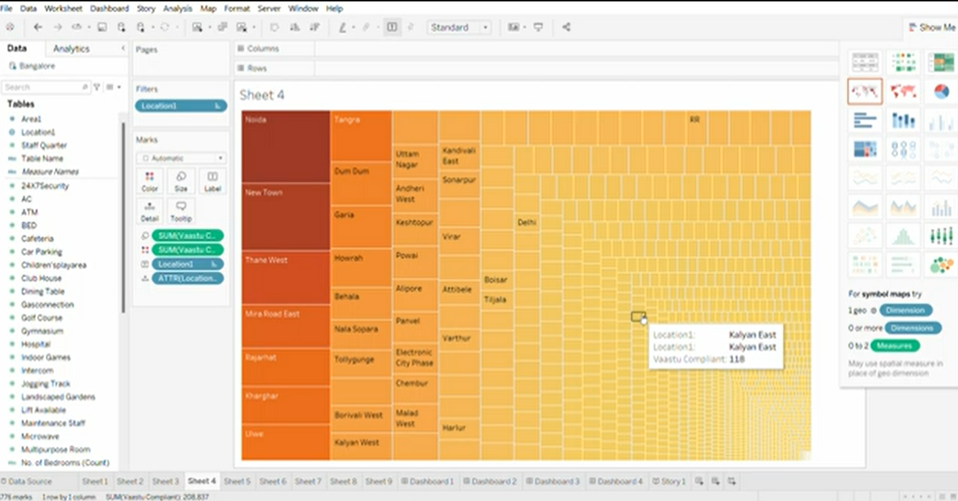

* + Click the sheet 4.
  + Drag the location to the filters.
  + Drag the vaastu complains to the tooltip and colors.
  + Then drag the location to the text.
  + Then drag the ATTR(location) to the detail.
  + Then save the sheet by name sheet4.

**ACTIVITY 1.5:**

**HOUSE PRICE BASED ON NUMBER OF BEDROOMS EXPLANATION VIDEO LINK:**

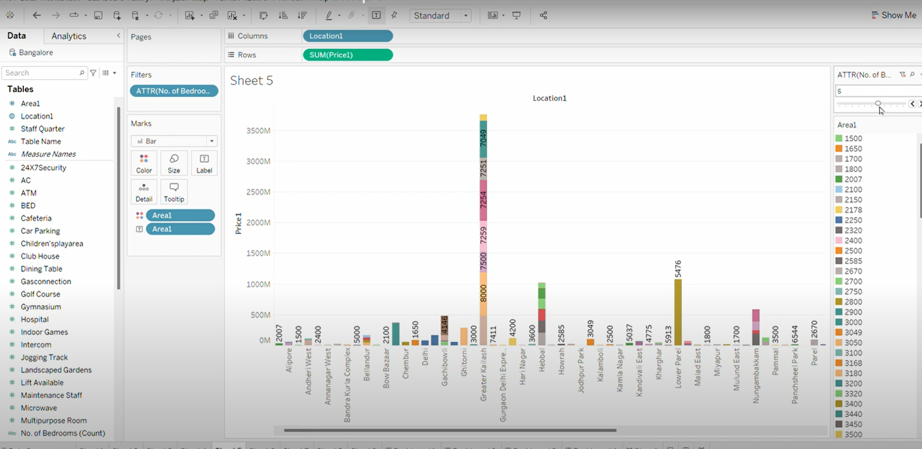

* + Click sheet 5.
  + Drag the location to the X-axis.
  + Then drag the SUM(price) to the Y-axis.
  + Add filters ATTR(No. of bedrooms) in the filter box.
  + Drag the area to colors and text .
  + Change the option to the bar.
  + Then the sheet appears ,then save the sheet as sheet 5.

**ACTIVITY 1.6:**

**HOSPITALS AND SCHOOLS NEAR THE HOUSES**

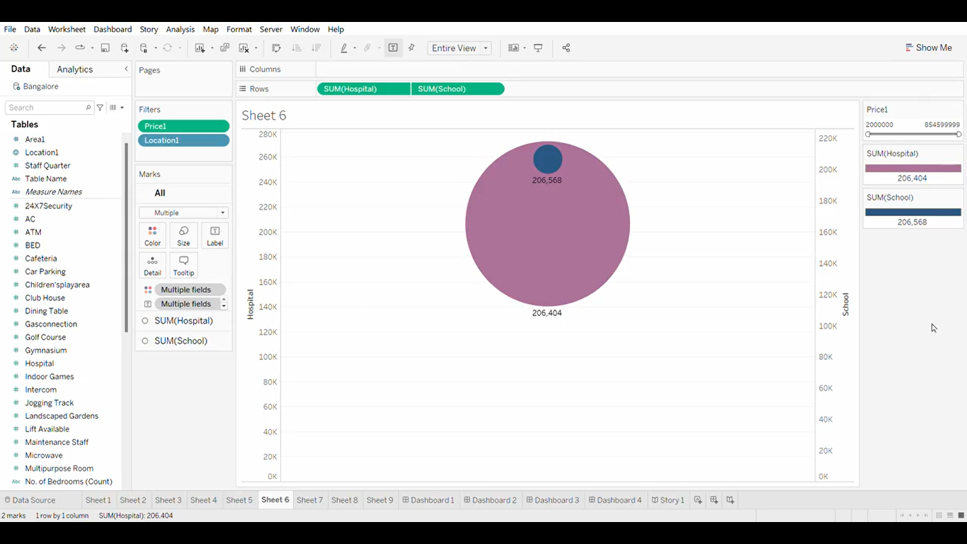

* + Click sheet 6 then the sheet appears.
  + Drag SUM(hospital) and SUM(school) to Y-axis.
  + Add the price and location in the filters.
  + Drag multiple fields to the color and label.
  + Then all the filters were appeared.
  + Save the sheet as sheet 6.

**ACTIVITY 1.7:**

**MAINTAINS STAFF IN HOUSES PRICES**

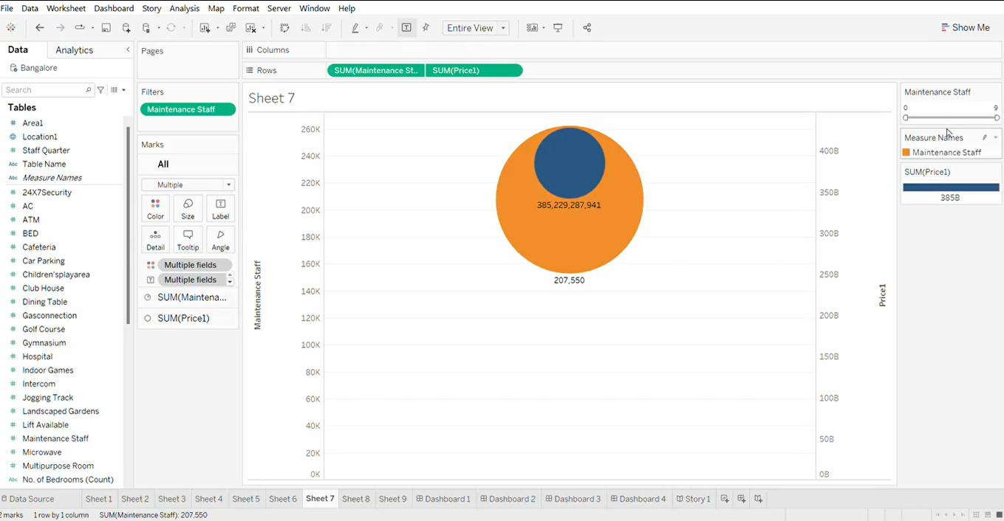

* + Click sheet 7 then the sheet 7 appears.
  + Drag the SUM(maintenance staff) and SUM(price) to the Y-axis.
  + Add maintenance staff in filters.
  + Drag the multiple fields in color and label.
  + Then select the color which you want.
  + Then save the sheet as sheet 7 by clicking save button.

**ACTIVITY 1.8 :**

**HOUSE PRICE AND INTERCOM**

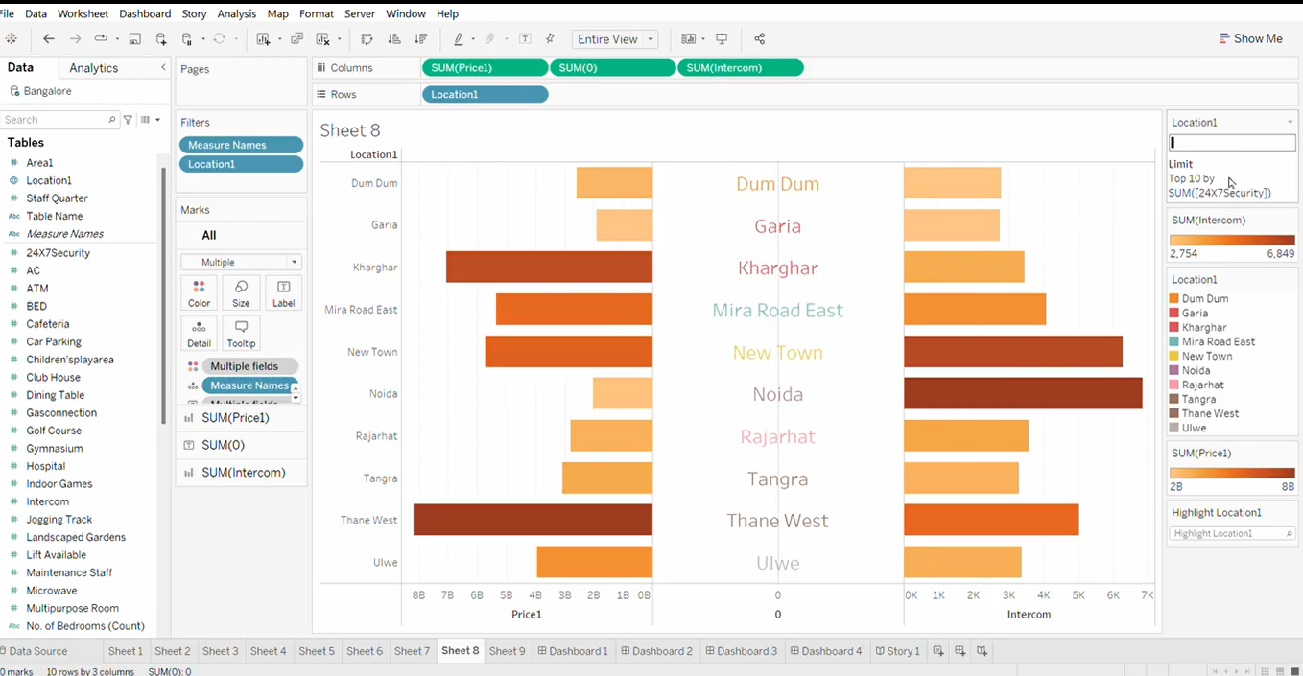

* + Click sheet 8 then the sheet appears.
  + Drag the SUM(price),SUM(0) and SUM(intercom) to the X-axis.
  + Then drag the location to the Y-axis.
  + Then the data appears.
  + Add measure names and location in the filters.
  + Drag the multiple fields to the color and multiple names to the tooltip.
  + Then the sheet appears.
  + Save this sheet as sheet8 by save option.

**ACTIVITY 1.9:**

**ALL SERVICES BASED ON LOCATIONS**

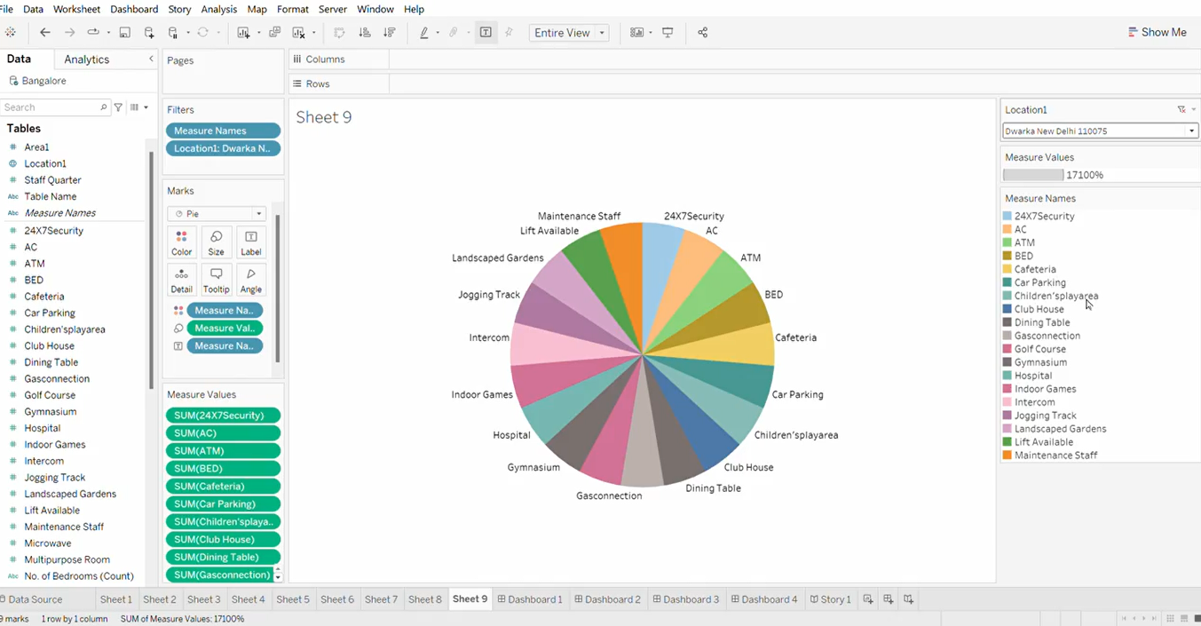

* + Click the sheet 9then the sheet 9 appears.
  + Drag the measure names and location to the filters.
  + Drag the measure names in color and label.
  + Then choose pie as option.
  + Then the pie appears with different colors and names.
  + Add all the names as measure names.
  + Then the pie appears .
  + Finally save the sheet as sheet 9 by clicking save option.

**MILESTONE 5**

**DASHBOARD**

A dashboard is a graphical user interface (GUI) that displays information and data in an organized, easy-to-read format. They can be used to track key performance indicators (KPIs), monitor performance metrics, and display data in the form of charts, graphs and tables.

**ACTIVITY 1**

**RESPONSIVE AND DESIGN OF DASHBOARD**

**DASHBOARD1:** 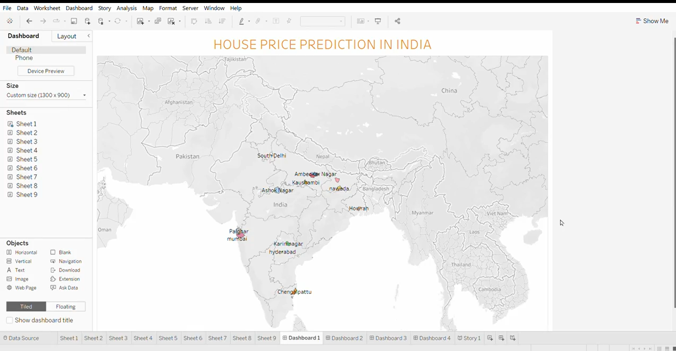

* + Click dashboard 1 then dashboard appears.
  + Drag sheet 1 in the dashboard.
  + Then save the dashboard as dashboard 1.

https://public.tableau.com/app/profile/jeevitha.m4719/viz/Dashboard1_16968417403170/Dashboard1?publish=yes#WelcomeQuestionnaire

**DASHBOARD 2:**

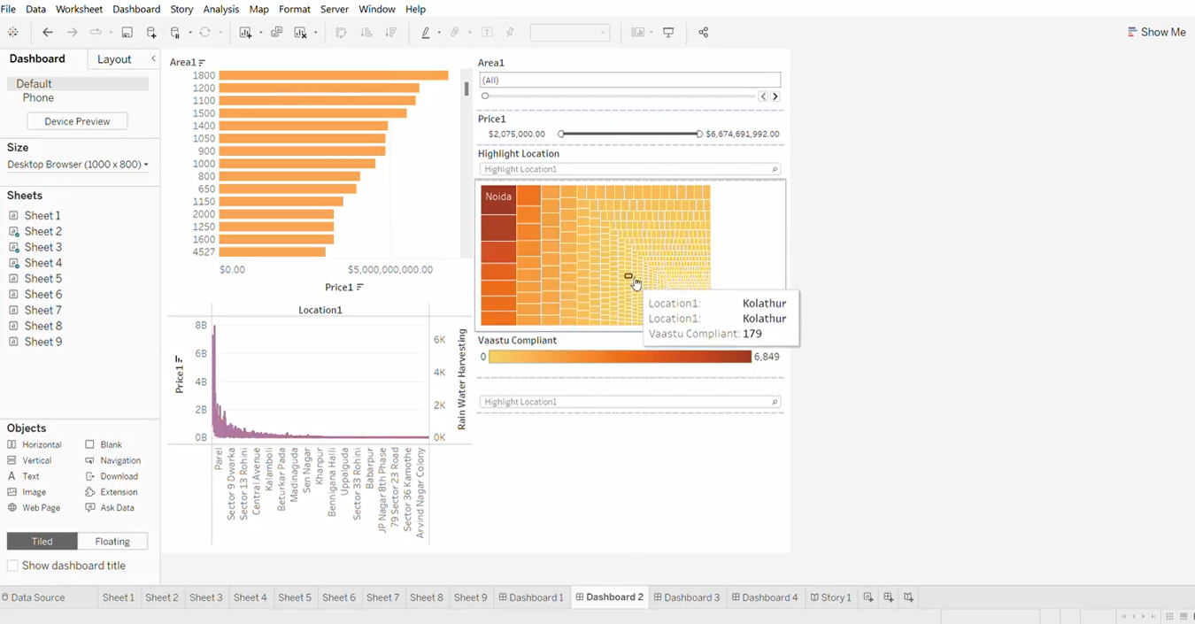

* + Click dashboard 2 then the dashboard screen appears.
  + Drag sheet2, sheet 3and sheet 4 to the dashboard.
  + Then save the dashboard as dashboard 2.

<https://public.tableau.com/app/profile/jeevitha.m4719/viz/Dashboard2_16968430321110/Dashboard2?publish=yes>

**DASHBOARD 3:**

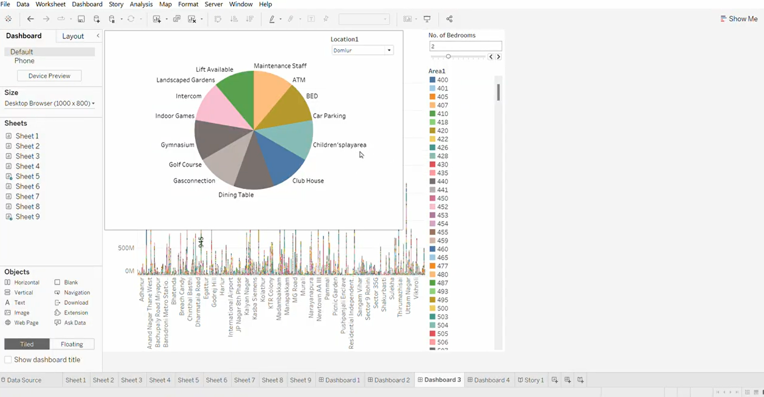

* + Click the dashboard 3 then the dashboard appears.
  + Drag the sheet 5 and sheet 9 to the dashboard.
  + Then save the dashboard.

<https://public.tableau.com/app/profile/jeevitha.m4719/viz/Dashboard3_16968431817900/Dashboard3?publish=yes>

**DASHBOARD 4:**

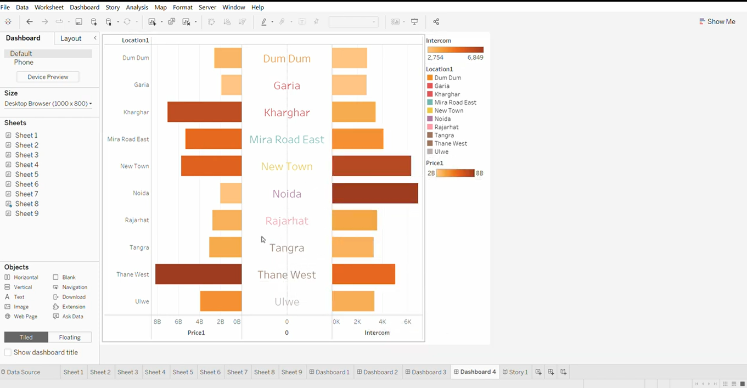

* + Click dashboard 4 then dashboard appears.
  + Drag sheet8 to the dashboard.
  + Then save the dashboard.

<https://public.tableau.com/app/profile/jeevitha.m4719/viz/Dashboard4_16968433026050/Dashboard4?publish=yes>

**MILESTONE 6:**

**STORY**

A data story is a way of presenting data and analysis in a narrative format, intending to make the information more engaging and easier to understand. A data story typically includes a clear introduction that sets the stage and explains the context for the data, a body that presents the data and analysis logically and systematically, and a conclusion that summarizes the key findings and highlights their implications.

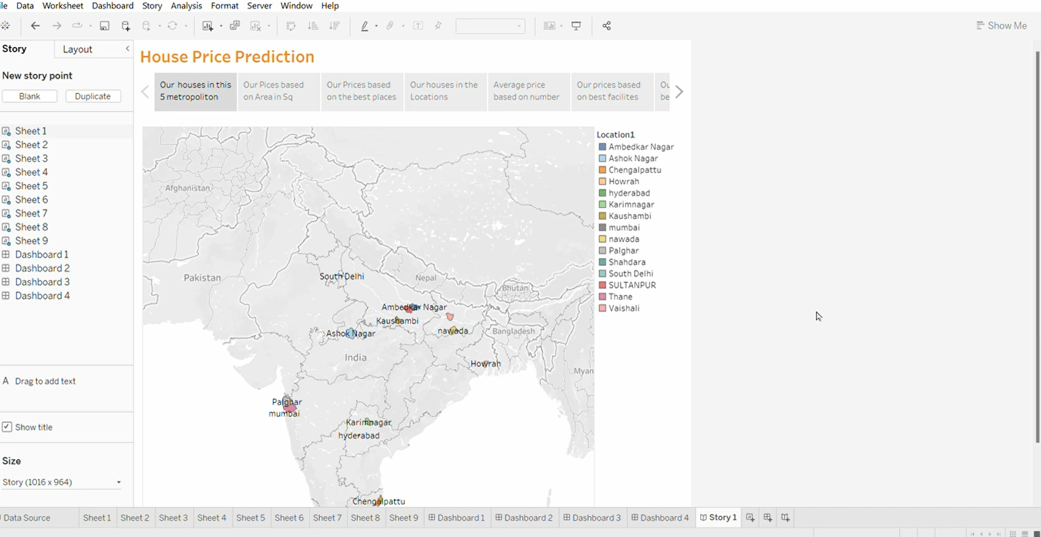

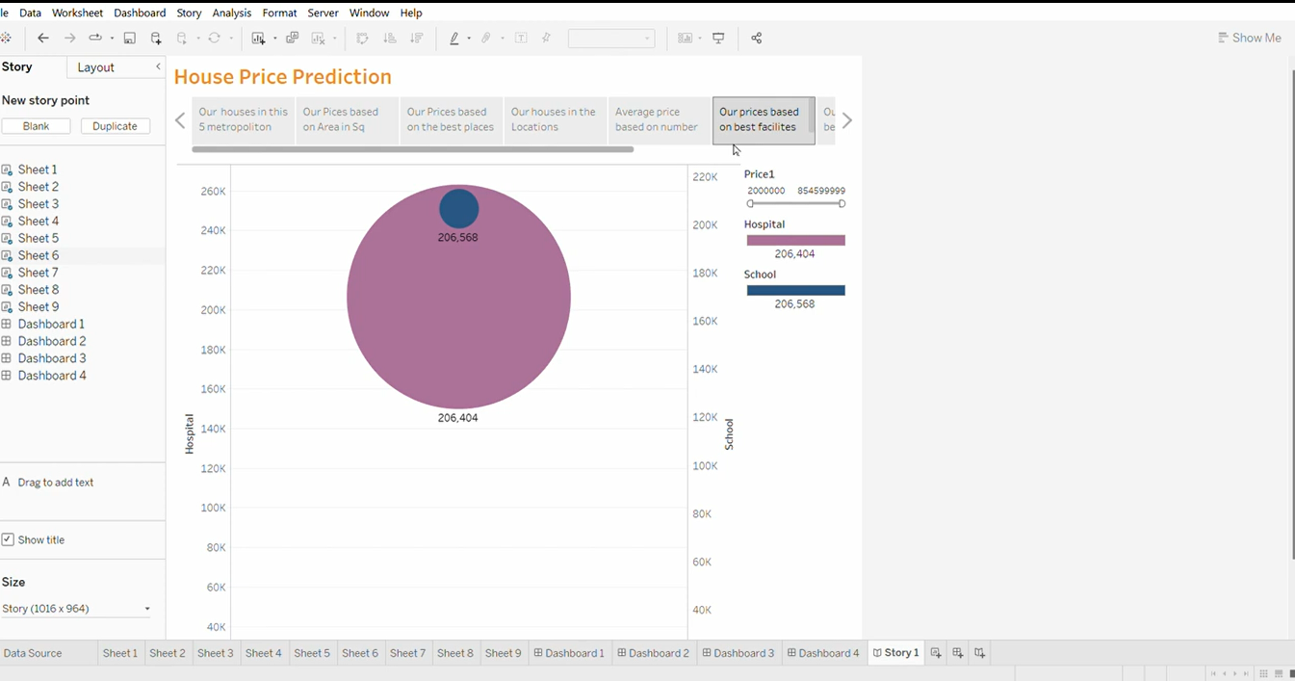

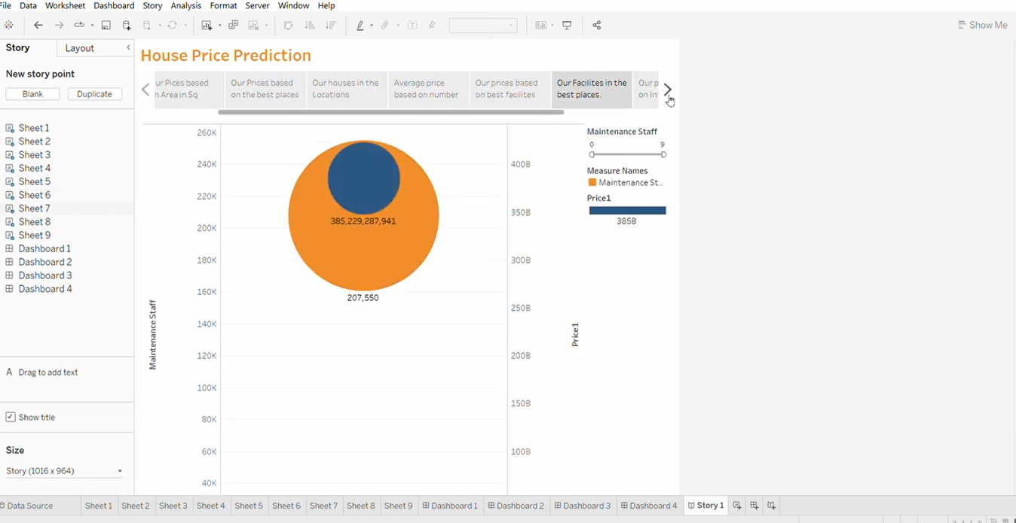

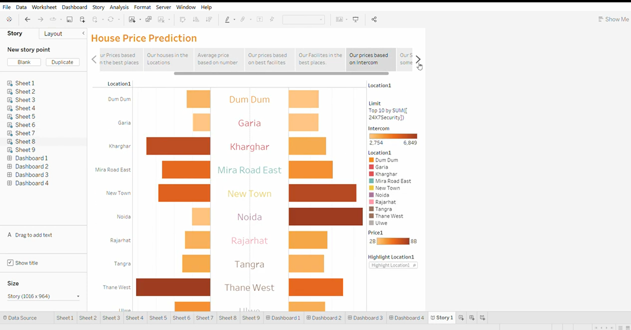

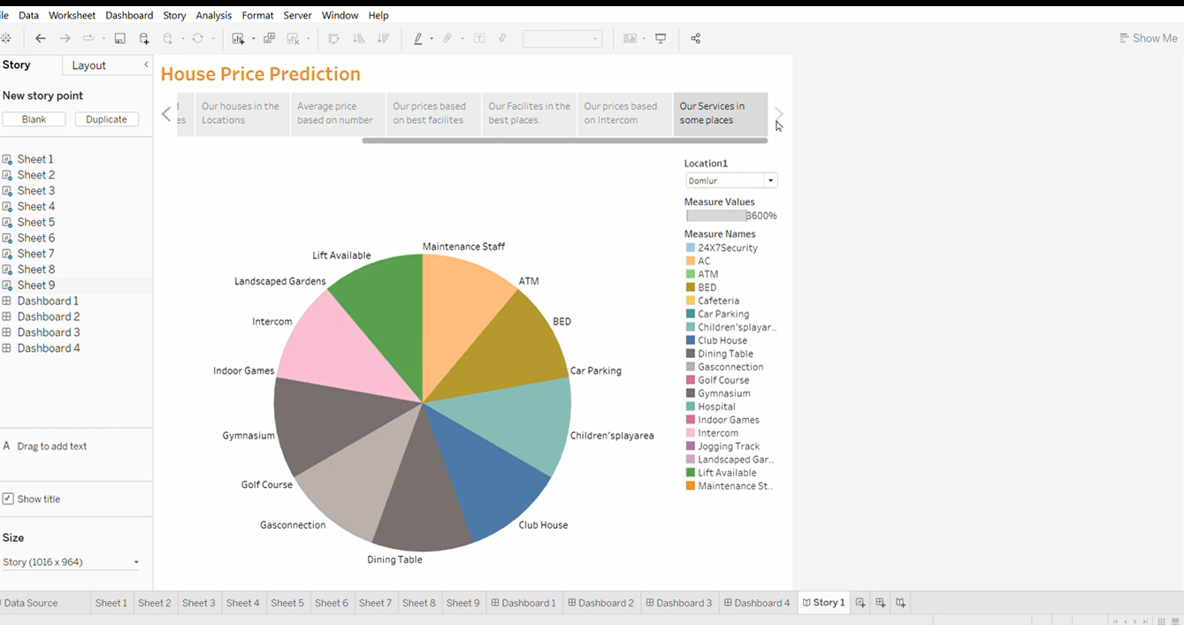

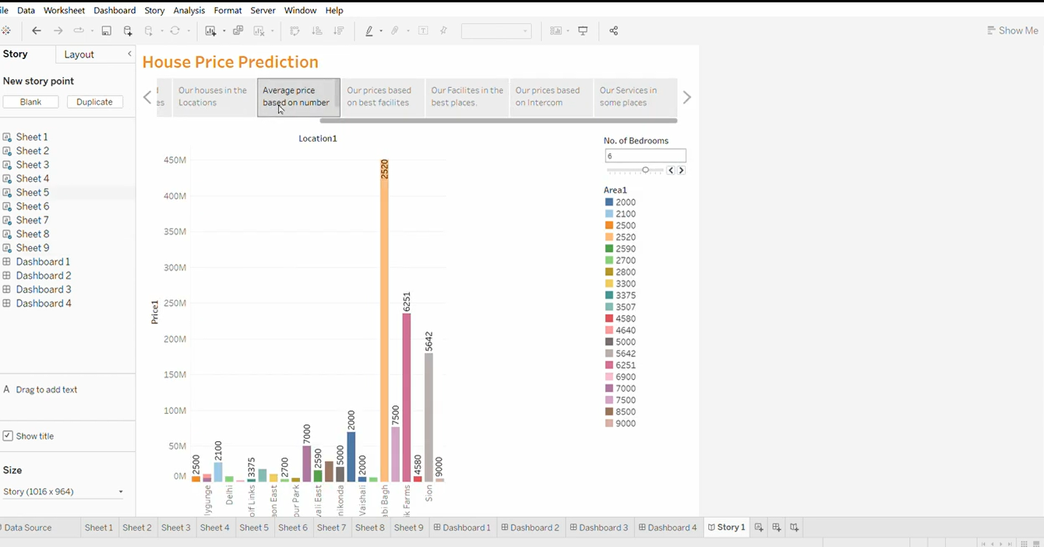

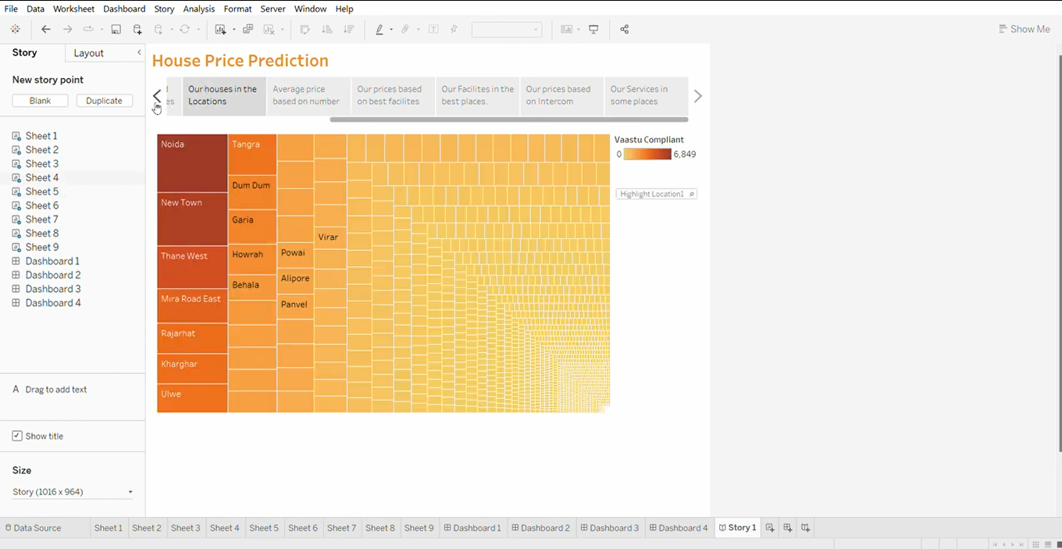

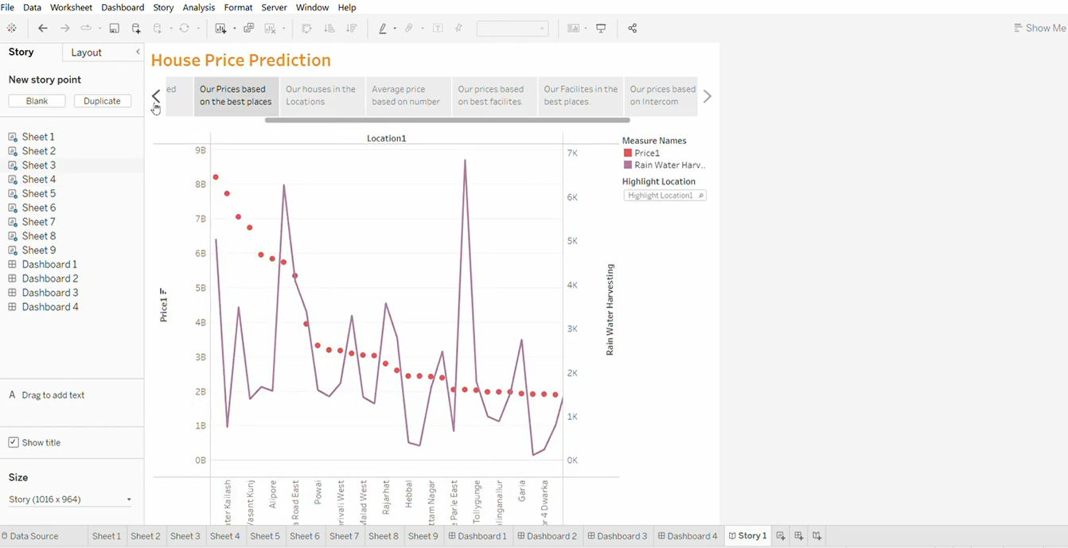

* + Click story.
  + Drag all the 9 sheets to the story.
  + Then save the story.

<https://public.tableau.com/app/profile/jeevitha.m4719/viz/Story_16968440208820/Story1?publish=yes>

**MILESTONE 7**

**PERFORMANCE TESTING:**

**Activity 1: UTILIZATION OF FILTERS**





**ACTIVITY 2:**

**NO OF VISUALIZATIONS/ GRAPHS:**

1. Latitude and Longitude based on Location.
2. Number of houses based on area in square feet.
3. Houses price based on rainwater harvest pits.
4. Vastu -complains based on location.
5. House price based on Number of Bedrooms.
6. Hospitals and schools near the Houses.
7. Maintains staff in houses prices.
8. House Price and Intercom.
9. All Services based on location.

**MILESTONE 8:**

**PUBLISHING**

Publishing helps us to track and monitor key performance metrics and to communicate results and progress. help a publisher stay informed, make better decisions, and communicate their performance to others.

**PUBLISHING DASHBOARD AND REPORTS TO TABLEAU:**

**STEP 1:**

Go to data Source and Select Extract so that .hyper extension files are created and save it at your desktop. (please wait for pop up of file to save)

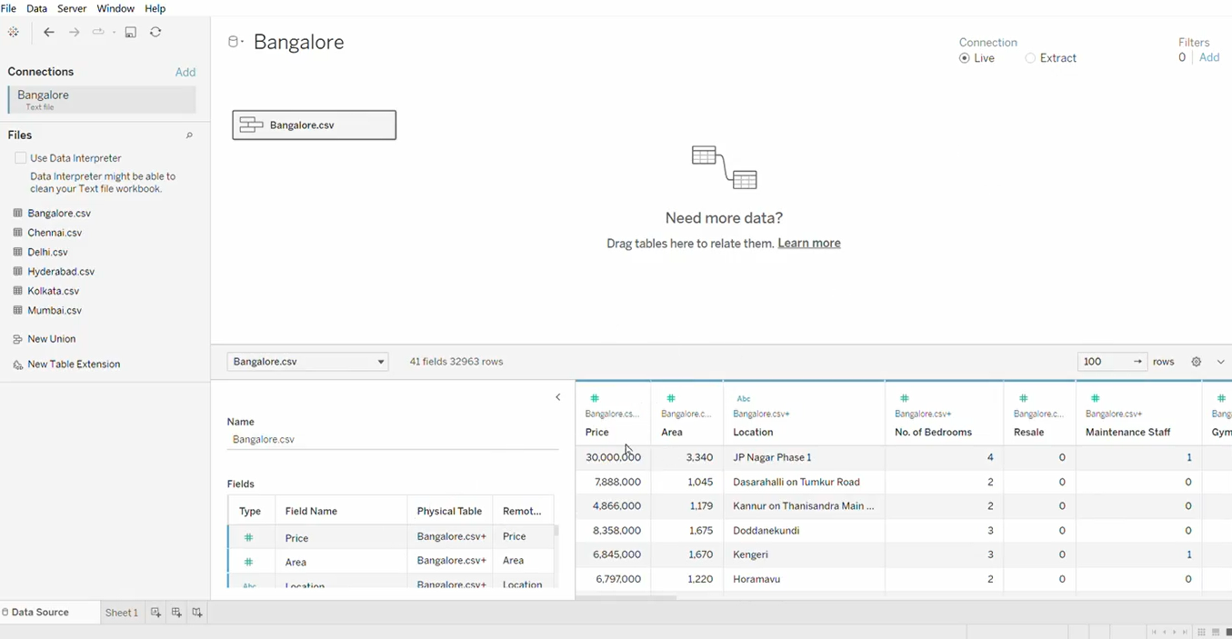

Step 2: Go to Dashboard/story, click on the share button on the top ribbon

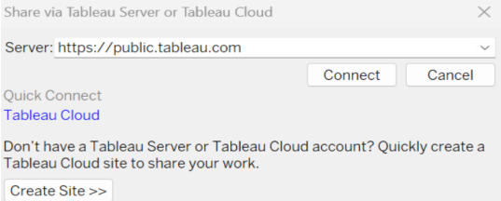

Give the server address of your tableau public account and click on connect.

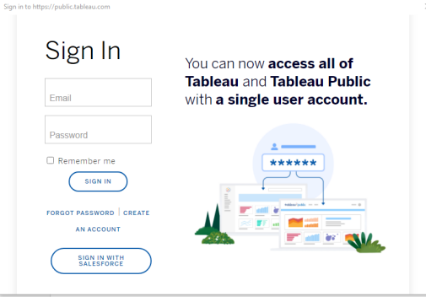

Sign in to your Tableau Public account or create a new account if you don't have one. You can visit the Tableau Public website (public.tableau.com) and click on the "Sign In" or "Join" button. In the "Tableau Public Sign In" window, enter your Tableau Public account credentials and click "Sign In." Next, you'll need to provide a title and description for your workbook. Fill in the appropriate details in the provided field of workbook Title.

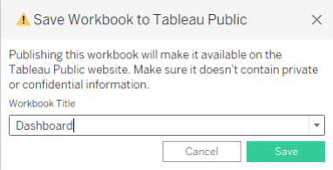

Click on the "Save" button to start the publishing process. Tableau Desktop will upload your workbook to Tableau Public. Once the upload is complete, a browser window will automatically open, displaying your published workbook on Tableau Public.

Review the workbook to ensure that everything appears as expected. So in Similar way we can also publish Story to tableau public. Once you login into your tableau public using the credentials, the particular visualization will be published into the tableau public.

**5.ADVANTAGES AND DISADVANTAGES**

**ADVANTAGES:**

**APPRECIATION POTENTIAL:**

House prices in metropolitan areas often have a higher potential for long term appreciation due to population growth, economic development, and urbanization.

**RENTAL INCOME:**

Investing in metropolitan areas can provide a steady stream of rental income, as there is generally a higher demand for rental properties in cities.

**AMENITIES AND INFRASTRUCTURE:**

Metropolitan areas offer better amenities, infrastructure, and services, making them attractive to residents and tenants.

**EMPLOYMENT OPPORTUNITIES**:

Major cities are economic hubs with diverse employment opportunities , which can lead to higher demand for housing.

**EDUCATION AND HEALTHCARE:**

Access to quality education and healthcare facilities is typically better in metropolitan areas, making them desirable for families.

**DISADVANTAGES:**

**HIGH PROPERTY PRICES:**

One of the most significant disadvantages is the high cost of real estate in metropolitan areas. This can be a barrier to entry for many investors and homebuyers.

**COMPETITION**:

Due to high demand, there can be intense competition for properties, leading to bidding wars and inflated prices.

**TRAFFIC AND CONGESTION:**

Many metropolitan areas face issues of traffic congestion and limited parking, which can negatively impact the quality of life for residents.

**POLLUTION:**

Pollution levels are often higher in cities, affecting air and water quality and overall health.

**LIMITED GREEN SPACES:**

Metropolitan areas may have limited green spaces and recreational areas, making it challenging for residents to find open and natural spaces for relaxation.

**6.APPLICATIONS**

Analyzing housing prices in metropolitan areas in India has numerous applications that can be beneficial for various stakeholders, including government authorities, real estate developers, investors, and prospective homebuyers.

Investors can use housing price analysis to identify potential investment opportunities in metropolitan areas. They can assess trends, forecast future price movements, and make informed decisions about buying, selling, or holding real estate assets.

**7.CONCLUSION**

The Indian real estate market is currently experiencing a period of growth, with housing prices rising in several cities across the country. Factors such as low interest rates, government initiatives, infrastructure development, and favorable demographic have contributed this to the upward trend. This growth can be attributed to various factors, including increased demand, favorable government policies, and a recovering economy.

**8.FUTURE SCOPE**

1. LOCATION: Proximity to city centers, public transportation amenities, and neighborhood desirability.

2. PROPERTY TYPE: Apartment, villa, independent house etc..

3. SIZE AND SPACE: Square footage, number of rooms, bathrooms and amenities.

4. MARKET TRENDS: Historical pricing data, price fluctuation, and market demand.

**PROJECT LINK:**

**DASHBOARD LINK:**

**DASHBOARD 1:**

<https://public.tableau.com/app/profile/jeevitha.m4719/viz/Dashboard1_16968417403170/Dashboard1?publish=yes#WelcomeQuestionnaire>

**DASHBOARD 2:**

<https://public.tableau.com/app/profile/jeevitha.m4719/viz/Dashboard2_16968430321110/Dashboard2?publish=yes>

**DASHBOARD 3:**

<https://public.tableau.com/app/profile/jeevitha.m4719/viz/Dashboard3_16968431817900/Dashboard3?publish=yes>

**DASHBOARD 4:**

<https://public.tableau.com/app/profile/jeevitha.m4719/viz/Dashboard4_16968433026050/Dashboard4?publish=yes>

**STORY:**

<https://public.tableau.com/app/profile/jeevitha.m4719/viz/Story_16968440208820/Story1?publish=ye>

**PROFILE:**

<https://public.tableau.com/app/profile/jeevitha.m4719/vizzes>

**MILESTONE 9:**

**PROJECT DEMONSTRATION & DOCUMENTATION**

Below mentioned deliverables to be submitted along with other deliverable

**VIDEO DEMONSTRATION LINK:**

[**https://drive.google.com/file/d/1bDc5NOF00cBa7ILKKcnRyj7LoHGhkfLL/view?usp=sharing**](https://drive.google.com/file/d/1bDc5NOF00cBa7ILKKcnRyj7LoHGhkfLL/view?usp=sharing)